Name: Um-e-Hani Enrollment: 03-135232-074

📘 Content Management Systems (CMS)

🧪 Lab Manual – Week 1

🔹 Lab Title
Introduction to CMS & WordPress Environment

🔹 Lab Duration
2–3 Hours

🔹 Lab Objectives
After completing this lab, students will be able to:
- Understand what a CMS is in practical terms
- Identify different CMS platforms
- Set up a local development environment
- Install WordPress successfully
- Access and explore the WordPress dashboard
- Understand basic CMS workflow (Login → Create → Publish)

🔹 Software / Tools Required
- Computer or Laptop
- Internet Browser (Chrome / Firefox)
- XAMPP or WAMP Server
- Latest WordPress package
- Text Editor (optional – Notepad++)

🔹 Basic Concepts (Quick Review)

What is CMS?
A CMS allows users to create and manage website content without coding.

What is WordPress?
- Open-source CMS
- Written in PHP
- Uses MySQL database
- Most widely used CMS in the world

🧪 Lab Task 1: Identify Popular CMS Platforms

Instructions:
- Open your browser
- Search for examples of CMS platforms
- Write names of at least 5 CMS platforms
- WordPress
- Joomla
- Drupal
- Magento
- Shopify

🧪 Lab Task 2: Install Local Server (XAMPP)

Step-by-Step Instructions:
- Go to https://www.apachefriends.org
- Download XAMPP for Windows
- Install XAMPP using default settings
- Open XAMPP Control Panel
- Start Apache and MySQL services

Verification:
- Open browser
- Type: http://localhost
- XAMPP dashboard should appear
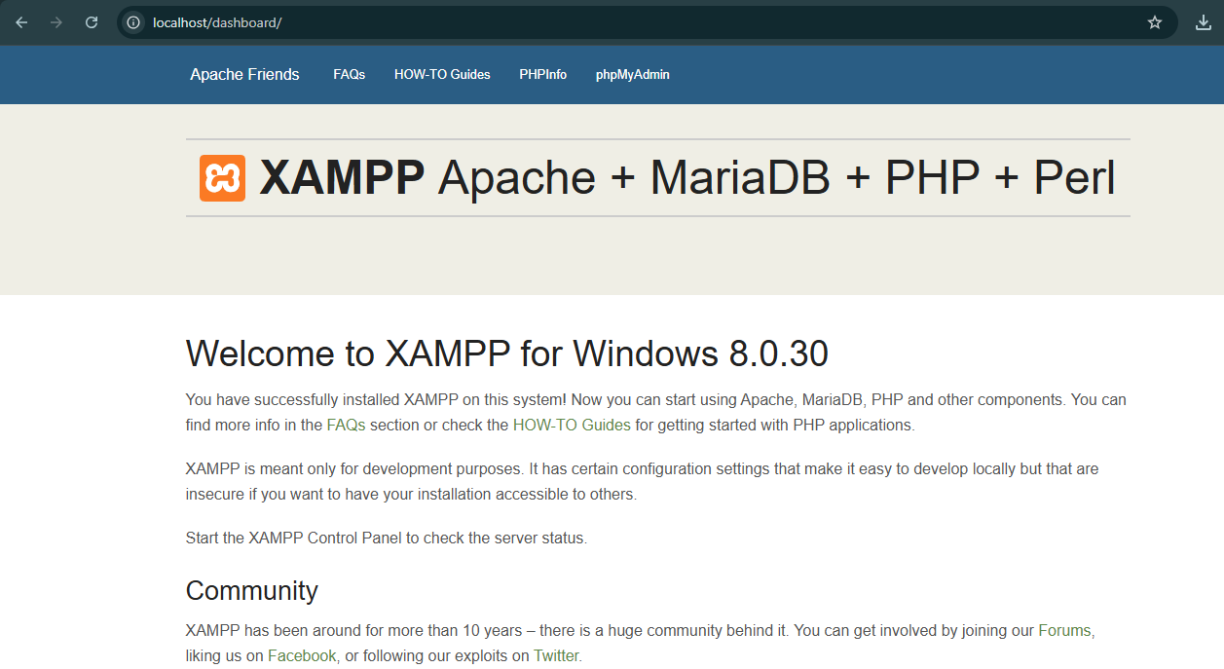
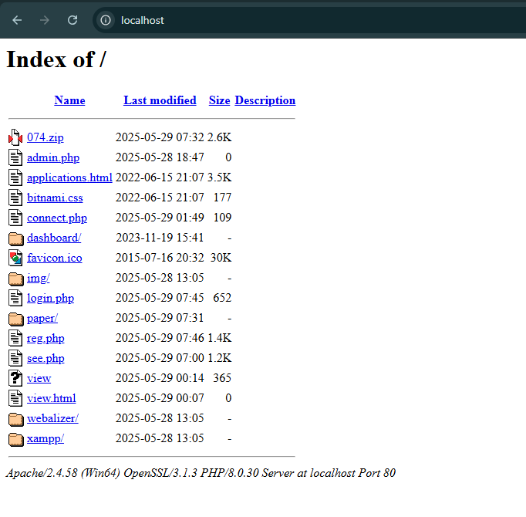

🧪 Lab Task 3: Download & Extract WordPress

Steps:
- Visit https://wordpress.org
- Download latest WordPress version
- Extract the ZIP file
- Copy the wordpress folder
- Paste it into: C:\xampp\htdocs
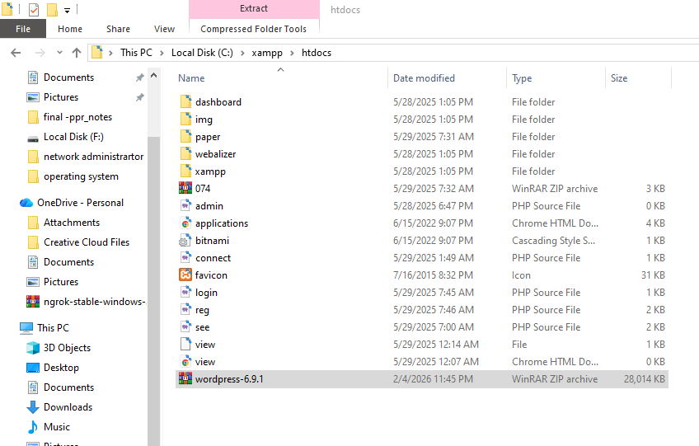

🧪 Lab Task 4: Create Database for WordPress

Steps:
- Open browser
- Go to: http://localhost/phpmyadmin
- Click New
- Database Name: cms_lab
- Click Create
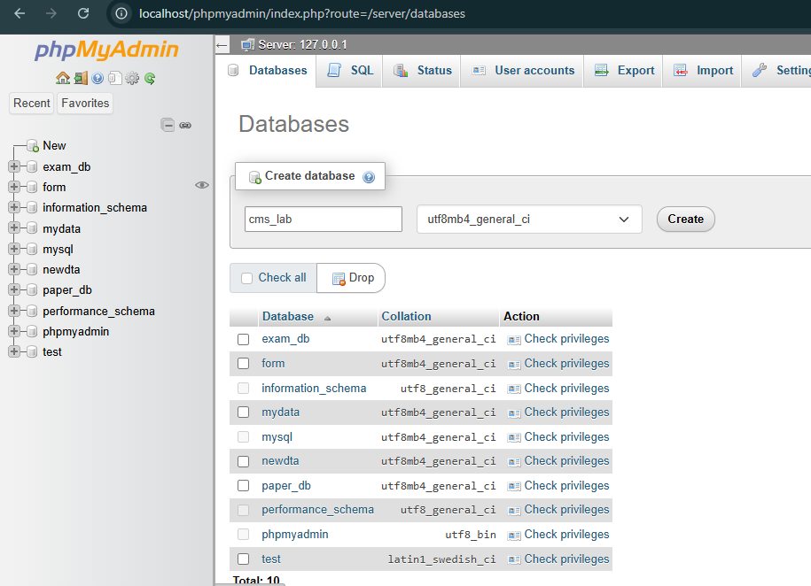
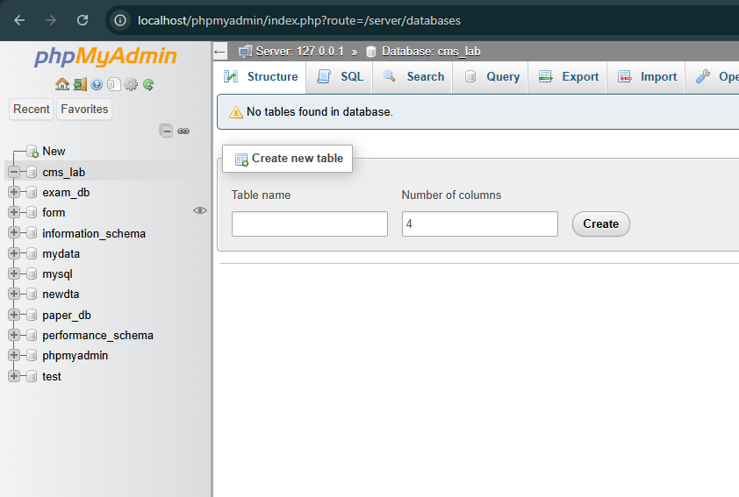

🧪 Lab Task 5: Install WordPress

Steps:
- Open browser
- Type: http://localhost/wordpress
- Select language
- Click Continue
- Enter database details:
Field | Value
Database Name | cms_lab
Username | root
Password | (leave empty)
Server | localhost
- Click Submit → Run Installation
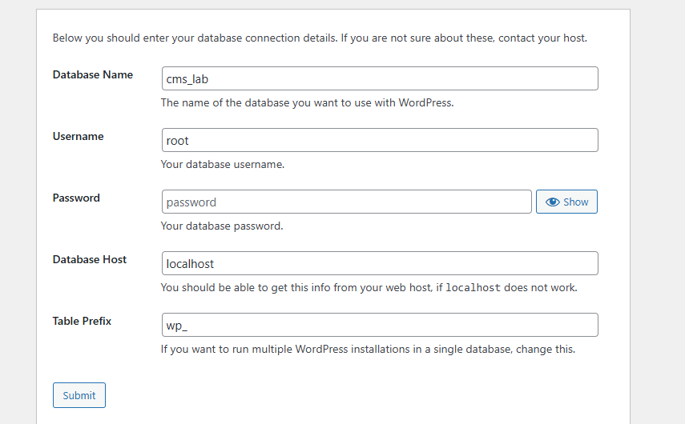
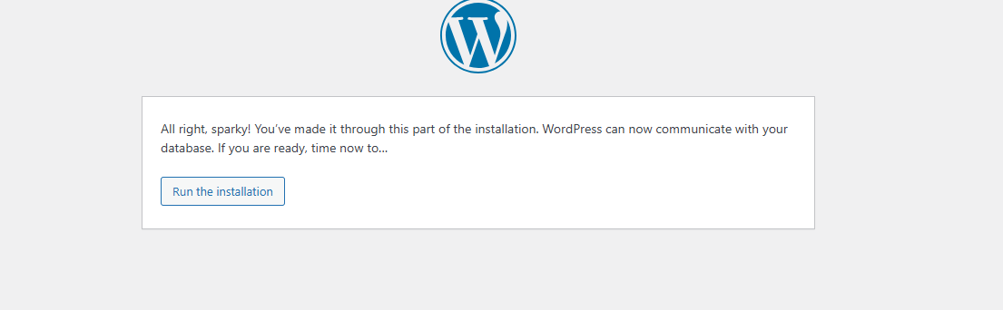

🧪 Lab Task 6: Create Admin Account

Fill the following details:
- Site Title: CMS Lab Website
- Username: admin
- Password: (Strong password)
- Email: your email
Click Install WordPress
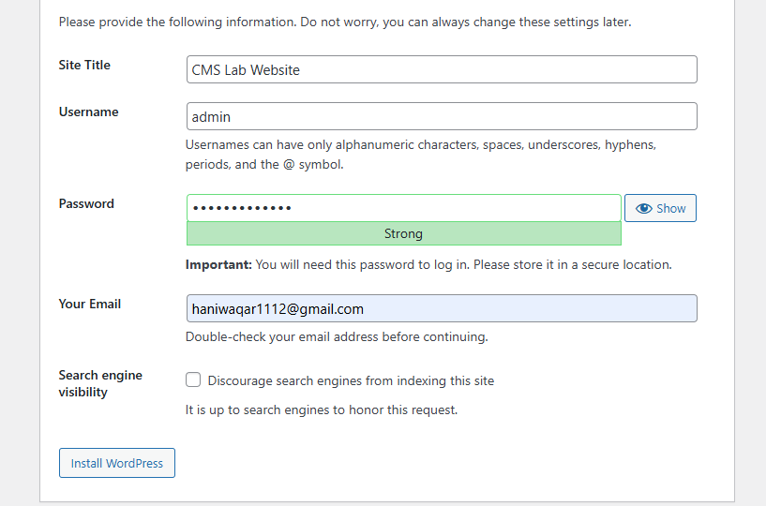

🧪 Lab Task 7: Explore WordPress Dashboard

After Login, Explore:
- Dashboard
- Posts
- Pages
- Appearance
- Plugins
- Users
- Settings

Task:
Write one-line purpose of each menu
• Dashboard: Shows an overview of the website, updates, and recent activity.
• Posts: Used to create and manage blog posts and articles.
• Pages: Used to create and manage static pages like Home, About, and Contact.
• Appearance: Used to change the theme, design, menus, and layout of the website.
• Plugins: Used to add new features and functionality to the website.
• Users: Used to add and manage users and their roles on the website.

🧪 Lab Task 8: Create First Post

Steps:
- Go to Posts → Add New
- Title: My First CMS Post
- Content: Write 3–4 lines
- Click Publish
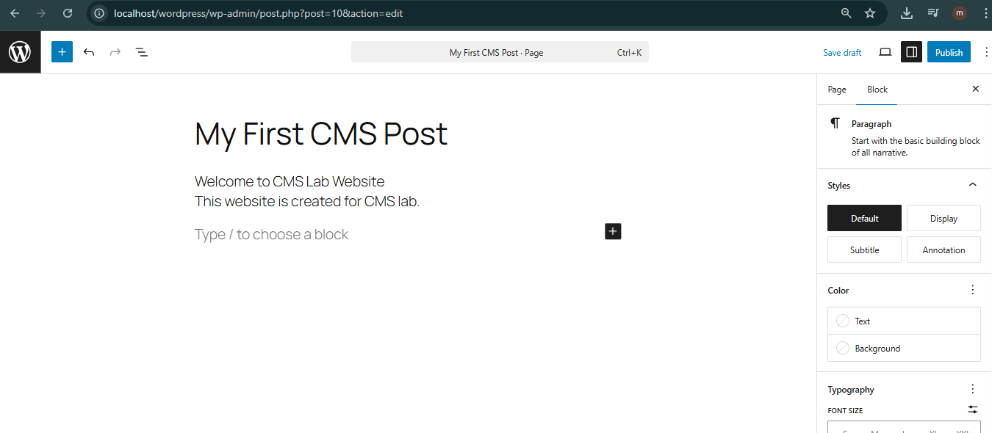

Output:
- Post visible on website homepage
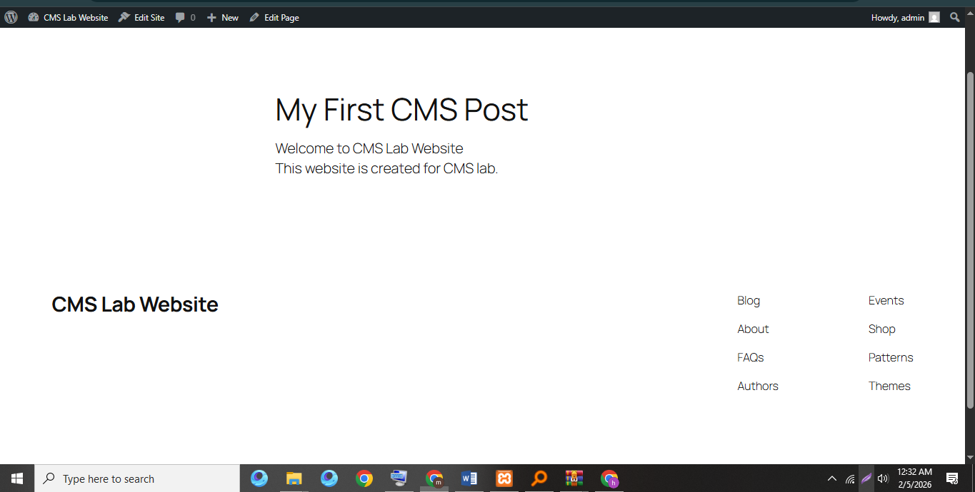

🧪 Lab Task 9: Create a Page

Steps:
- Go to Pages → Add New
- Title: About Us
- Write basic introduction
- Click Publish
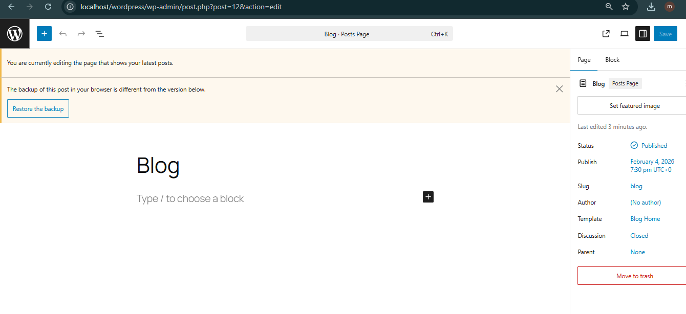

🧪 Lab Task 10: Change Website Theme

Steps:
- Go to Appearance → Themes
- Click Add New
- Install any free theme
- Activate theme

Observation:b
Website appearance changes instantly
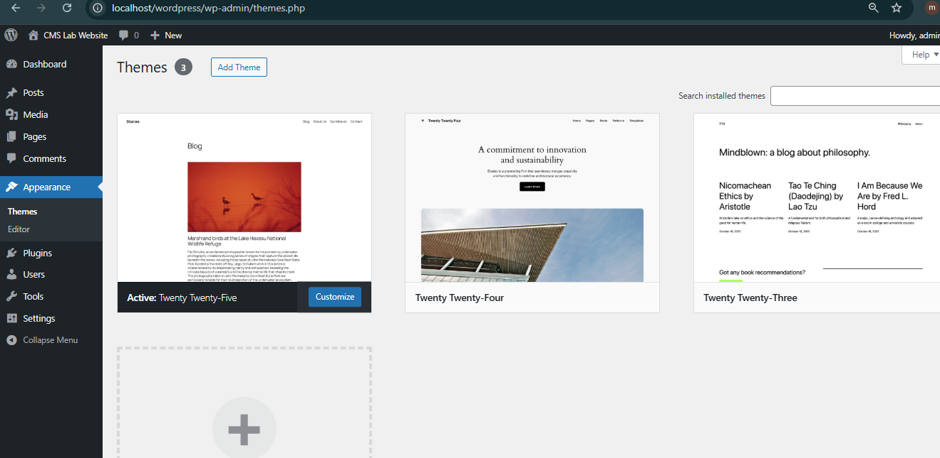
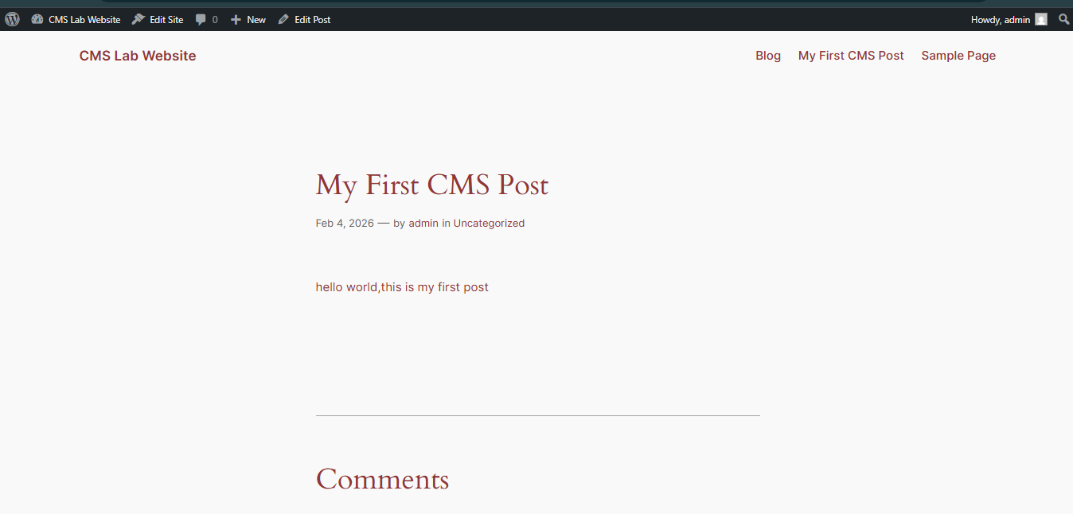
Link for the post
http://localhost/wordpress/?p=17

🔚 Conclusion
In this lab, students learned:
- CMS basics through practice
- Local server setup
- WordPress installation
- Content creation workflow
This lab builds the foundation for advanced CMS concepts.

📅 Next Lab Preview (Week 2)
- CMS Architecture
- Themes vs Plugins
- WordPress Settings
- User Roles

